

**Medicine Dictionary**

**Sprint 1**

**Done By:**

**Jeongyun Lee**

**Ronnel Mattew**

**Marc Visa**

**Eyad Al Hafi**

**Master's Degree in Informatics Engineering**

**Academic course 2020/2021**

**Lleida, November 9th**

The Team:

The medicine dictionary team is composed of 4 developers who are responsible for developing applications, creating diagrams and preparing documents. One of the team members will be The scrum master he or she is responsible for organizing and managing the team meeting, documents , tasks and github.

|  |  |
| --- | --- |
| Team members | Role |
| Jeongyun Lee | Scrum master |
| Ronnel Mattew | Financial expert |
| Marc Visa | Analist expert |
| Eyad Al Hafi | Developer |

User stories:

User story 1:

As a user I want to create a new account by email or facebook or gmail so that i can use the application with full features.

Acceptance Criteria:

Successful signup.

User story 2:

As a user I want to login to my account by email or facebook or gmail so that i can enter the application with full features.

Acceptance Criteria:

Successful login.

User story 3:

As a user I want to change my account password so that I can remember it better.

Acceptance Criteria:

Successful changing password process.

User story 4:

As a user I want to search for a specific medicine by name or characteristic(color,shape and coe) so that I can add it to my list.

Acceptance Criteria:

Reaching the targeted medicine.

User story 5:

As a user I want to set an for a specific pill alarm so that I can remember the time of taking the pill.

Acceptance Criteria:

Setting the alarm and running in the time successfully.

User story 6:

As a user I want to get notification so that it can follow daily guidelines that are related to my medicines.

Acceptance Criteria:

Getting the appropriate notifications.

User story 7:

As a user I want to get caution reminders so that I can avoid taking two conflicted pills that may affect my health.

Acceptance Criteria:

Warning me when I was in danger.

User story 8:

As a development team we want to find the environment, technologies and tools that we are going to work with so that we can know and learn more about them.

Acceptance Criteria:

Define the environment, used computer language and backend type.

User story 9:

As a development team we want to learn kotlin so that we can start developing our application.

Acceptance Criteria:

Completing the kotlin tutorials.

User story 10:

As a development team we want to learn more about firebase so that we can start developing our application with backend.

Acceptance Criteria:

Completing the firebase tutorials.

User story 11:

As a development team we want to find the best source of data so that we can add it to our database or use it.

Acceptance Criteria:

Defining the data source.

User story 12:

As a development team we want to create a mockup so that we can understand how our application will be.

Acceptance Criteria:

Having all pages that we need in our application that describe the general design, widgets and features.

User story 13:

As a development team we want to create the use case diagram so that we can understand the application entities and features better.

Acceptance Criteria:

Having a use case diagram that described the entities and features.

User story 14:

As a development team we want to create the db data model diagram so that we can understand and create our backend database easily.

Acceptance Criteria:

Having a db data model diagram that described our database tables.

User story 15:

As a development team we want to create the general architecture diagram so that we can know how we are going to build our application.

Acceptance Criteria:

Having the general architecture done that describes how we are going to build our application.

User story 16:

As a development team we want to create the product backlog and sprint explanation so that we can understand what we are going to do as a whole project and for each sprint.

Acceptance Criteria:

Having the product backlog and sprint explanation done that describes the steps that we are going to follow.

User story 17:

As a development team we want to fill and study the financial viability so that we can know how much we are going to spend, what we will gain and our business cash flow.

Acceptance Criteria:

Having the financial viability.

User story 18:

As a scrum master I want to manage the github and daily meetings so that I can organize the sprints processes.

Acceptance Criteria:

Having all the required tasks managed and organized.

User story 19:

As a development team we want to create the powerpoint presentation file so that we can present it at the required date.

Acceptance Criteria:

Having a powerpoint presentation file ready with all the requirements.

Sprint Backlog Task and explanation:

We prepared the sprint backlog and explanation to make it easier to understand what we are going to do and what we are going to follow.

Planning

● Data diagram. (UML diagram, model classes, relations, etc.)

● Workflow diagram of the main functionalities.

● System structure (Android + Firestore, Web Service + DB)

Product Backlog Item

● installing program, frameworks

● study frameworks

● Simple sign up, log in, log out

● Start menu with the logo of the app

● data structure : which data we need to use

System and building

● system connecting : android - firebase connecting (firestore)

● database : Fill the db with pills’ info?

function1 - searching pills

● Form asking the pills dose of the user and user’s family in daily life.

● UI : for function1 (searching pill with shape, color, code)

● backend : query,

● Search engine. (searching the pill by its shape, colour or code)

● Print the info of the searched pill. (ingredients, dosage, side effects, etc.)

&lt;function 2 - alarm notifications

● Alarm notifications. (time to take the medicine, dosage, etc.)

● backend : bring user data, set alarm

● alarm set

function 3 - caution notifications -issue : how to find conflicted

medicines?

● Caution notifications. (conflicted medicines, ) -- negotiable

sprints:

1st sprint:

● Installing program, frameworks:

For developing this application, we are going to use android studio IDE with java language, also we are going to use firebase (Firestore) to store our data.

● UI Mockup:

We did a mockup for our application for the login page by social media and normal way(with username and password), searching page for this page the user will have to choice to do the search the first choice is searching by medicine name and the second one will be by searching by color, shape and the code of the medicine, searching result page this page will give a list of medicines if there are more than medicine for the searching result and the medicine page will include all the information about a special medicine that the user choose it to check.

● study frameworks:

Most of us do not have enough experience with building android application, so we are going to learn more about it by watching android tutorial and firebase tutorials.

● Drawing the charts and diagrams:

We are going to draw the charts and diagrams that will help us to explain more about project like use cases chart and entity diagram

● Financial Factors:

For the first sprint we are going to finish everything related to financial part like cash flow, flow chart and ROI with NPV

● data structure: which data we need to use

We are going to get our data from cima website this website has all data about medicines that we are going to use.

● system connecting:

As we mentioned before we are going to use Firestore to store our data, so the first step will be connecting our application to Firestore.

● Simple sign up, log in, log out:

As an usual app the first page will be login and sign up page.

We are planning to use social media for example Facebook and

Gmail for signing up and logging in.

● Start menu with the logo of the app:

The menu will contain all main parts or features on our app that the user is going to use it.

● Searching engine:

The main feature in our app will be the searching feature we will allow the user to make the search by two ways first one is searching by medicine name and the second one will be searching by color, shape and code of the medicine.

2nd sprint

● Adding pills to user list:

This feature will allow the user to a medicine or pill to the user list that contains all the pills that the user use

● Alarm feature and notifications:

This feature will allow the user to set an alarm to remind the user about the pills that he/she use and to remind by notification the user about the time that he/she should use the pill.

3rd sprint

● Caution notifications:

This feature will help the user to do not take two medicine together that make any dangerous side effects together. That will be done by giving a notification that remind the user that he/she does not have to take those pills at the same time.

● Adding new medicine request:

This feature will allow the user to submit a request that ask about adding new medicine to our database that he/she didn’t found it, so our team will review the request and take the decision about adding it or not.

General Architecture:

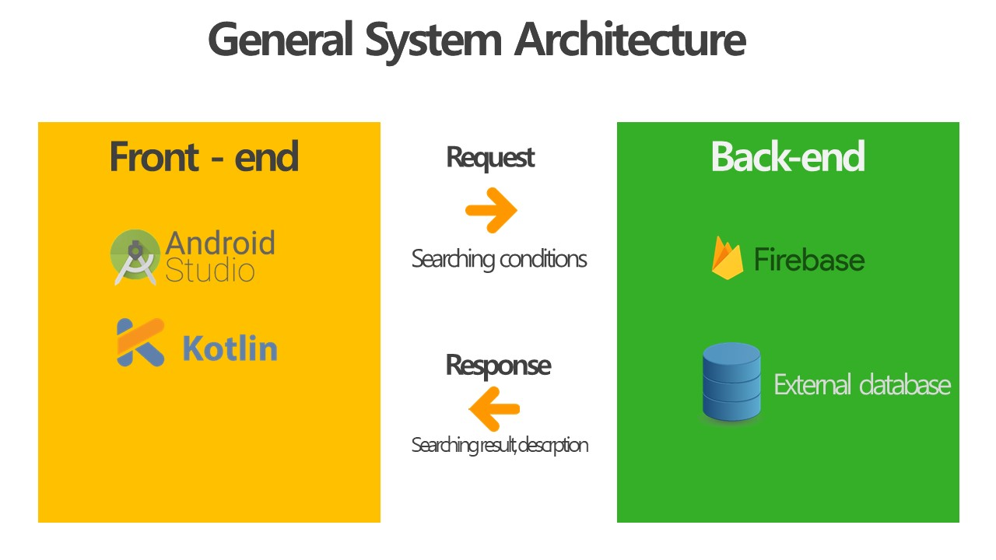

As the previous picture show we prepared the general architecture to help us to know what are the environment and tools that we are going to use.The picture shows that we choose to develop by using android studio IDE with kotlin language and we are going to use firebase to store our data.

Diagrams:

Use case diagram:

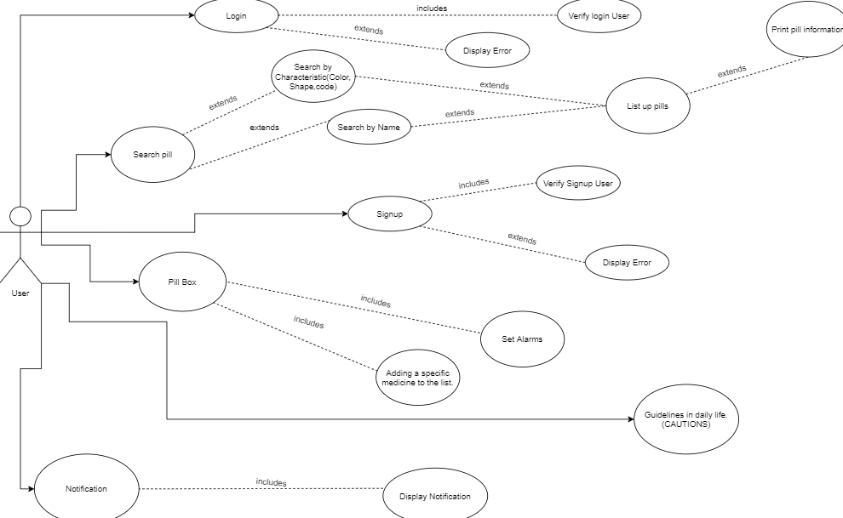

There are different functions that play a pivotal role in the Use Case scenario as seen in the Entity relationship diagram, they are:

1. **Signup ⇒** In the initial use case, the user would be able to sign up in the application. If the application has verified the user, it would lead the user to the sign in page; else it would display an error. The error would include, if the user does not have a proper internet connection or if the password entered does not consist of special characters.
2. **Login ⇒** In this use case, the user will be able to login to the application with the user’s proper login credentials. But, if the login id or the password is entered incorrectly, the application would display an error.
3. **Search pill ⇒** In this use case, the patients would like to have access to all the available information about any specific medicine. Moreover, this use case includes the following use cases:

* Characteristics: List up different pills according to the characteristics (color,shape,code) given on the search function and the option to add some of these pills to the pill box in order to set an alarm.
* Name: List the pills as per their names.
* Print pill info: This entity would print the information of the pills as per the size,color,shape and ingredients.

Additionally, there are some other use cases which extends the main use case. They are the search by color, the search by shape and the search by code.

1. **Pill box ⇒** In this use case, the patients would like to have all the medicines they take during the day in order to follow the doctor’s prescription.Moreover, this use case includes another use case which is when the user wants to set alarms based on the pills of the pill box, these alarms would act as a reminder to consume those medicines. The user would also have an entity that would include adding the specific medicine to the list inorder to remind them to take the pills.
2. **Guidelines ⇒** In this use case, the patients would be warned when there will be conflict with all the medicines they need to take. Besides, they would like to be cautioned if some medicines are incompatible with their diet.
3. **Notification** **⇒** In this use case, the application would display the list of pills from the pill box and the Search bar.

Db data model diagram:

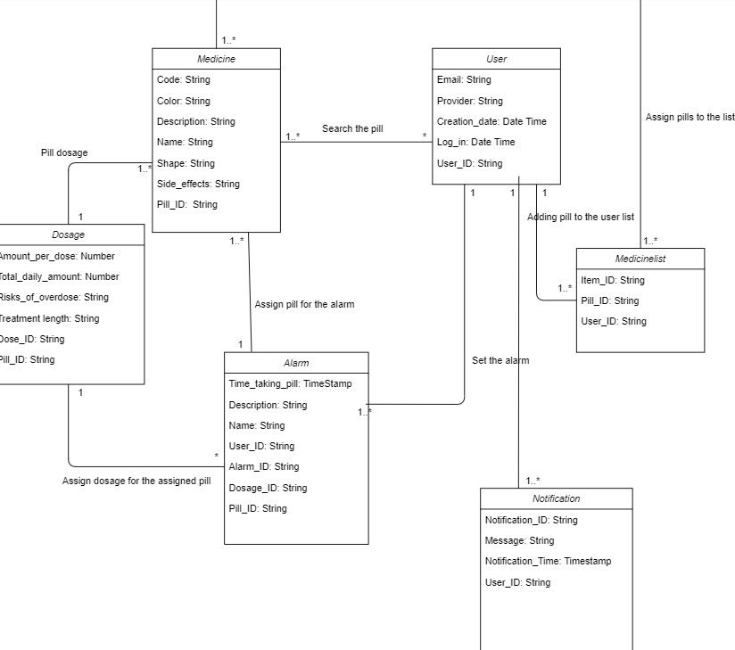

Entities

* **Medicine**: As for the medicines, we need to store the code, the color, shape and name for the searching function; moreover, a little description of the information pamphlet, which we would like to isolate the side effects since we believe that they are extremely important to take to account. Besides, for data management we would need the Pill_ID for each pill (medicine) as the primary key.
* **User**: Regarding the user authentication and management, we would need to store for each user, their email; the provider, of which they have accessed the app; the date when they had signed up, and their last login as well. Furthermore, for data management we would need the User_ID for each user as the primary key.
* **Alarm**: In respect of generating the alarms, we need to store the period of time in which the user has to take the medicine along the day; a name to title the alarm so the user could have a basic idea of the reason of the alarm; little description of what the alarm is for. Additionally, for data management we would need the User_ID for each user who sets the alarm as a foreign key, the Dosage_ID to have knowledge of what is the dose for the medicine which needs the alarm and therefore the Pill_ID, both foreign keys as well. Finally the Alarm_ID as the primary key.
* **Dosage**: Referring to the dosage, we would need to store the amount which the user has to take from the medicine, perhaps the total amount of the medicine in a day just to prevent the user from overdosing, and consequently, the risks of overdosing. In addition, the treatment length, to remind the user their medical prescription. Furthermore, for data management we would need the Pill_ID for matching a medicine with its pertinent dosage as a foreign key, and the Dose_ID as the primary key.
* **Notification:** A particular user can have multiple notifications that would be displayed with a caution message along with the notification time.
* **Medicine list:** The list of the medicines would be displayed when the user searches for the medicine and many pills can be added in the list. The list would consist of the pill_id and the user_id.

Relations

* **Search the pill** ( User -- Medicine ): A user might search at least one medicine along their session, whereas a medicine might be searched by many users or none.
* **Set the alarm** ( User -- Alarm ): A user might set many alarms or could be the possibility of none, whereas an alarm might be set only by one user.
* **Assign pill for the alarm** ( Alarm -- Medicine ): An alarm only needs one medicine to assign, so a medicine also goes with one alarm.
* **Assign dosage for the assigned pill** ( Alarm -- Dosage ): An alarm only needs one dosage per assigned pill, whereas a dose could be in many alarms or none.
* **Pill dosage** ( Medicine -- Dosage ): A medicine only has one dosage, whereas a dosage could be of more than one medicine.
* **Notification**  ( User -- Notification ): A user can have multiple notifications from the application.
* **Medicine list** ( Medicine -- List ): Many medicines can be assigned to the list that will consist of a list of multiple medicines  
  ( User -- List ): A user might add multiple numbers of medicines to the list.

Moc up:

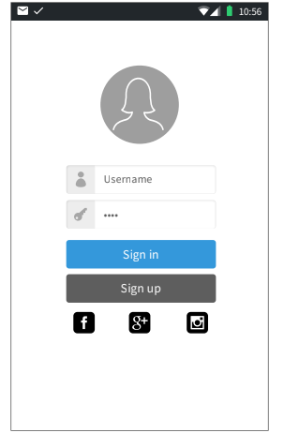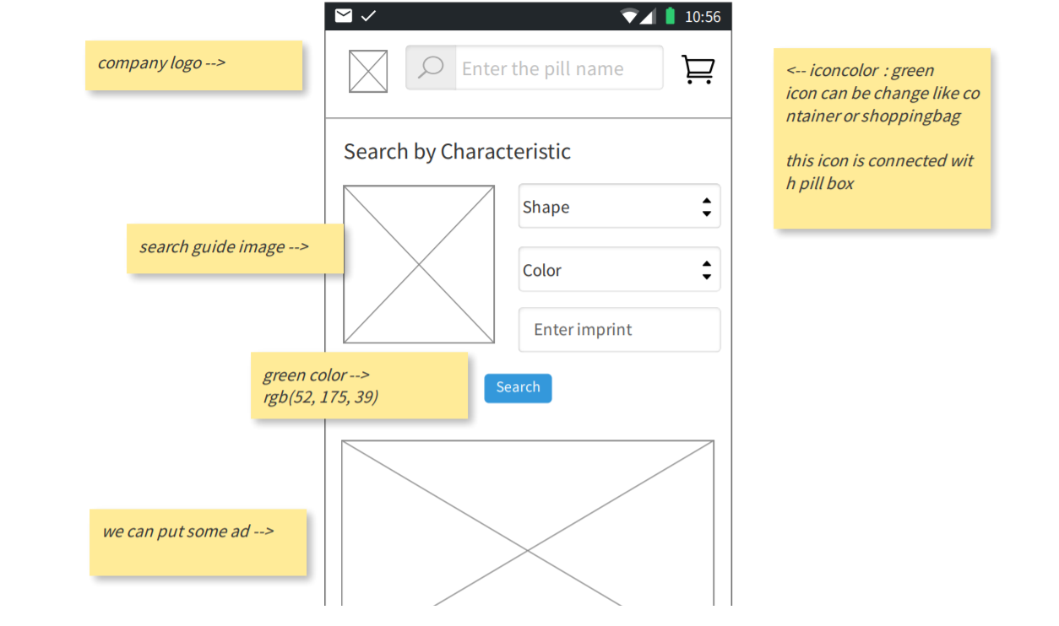

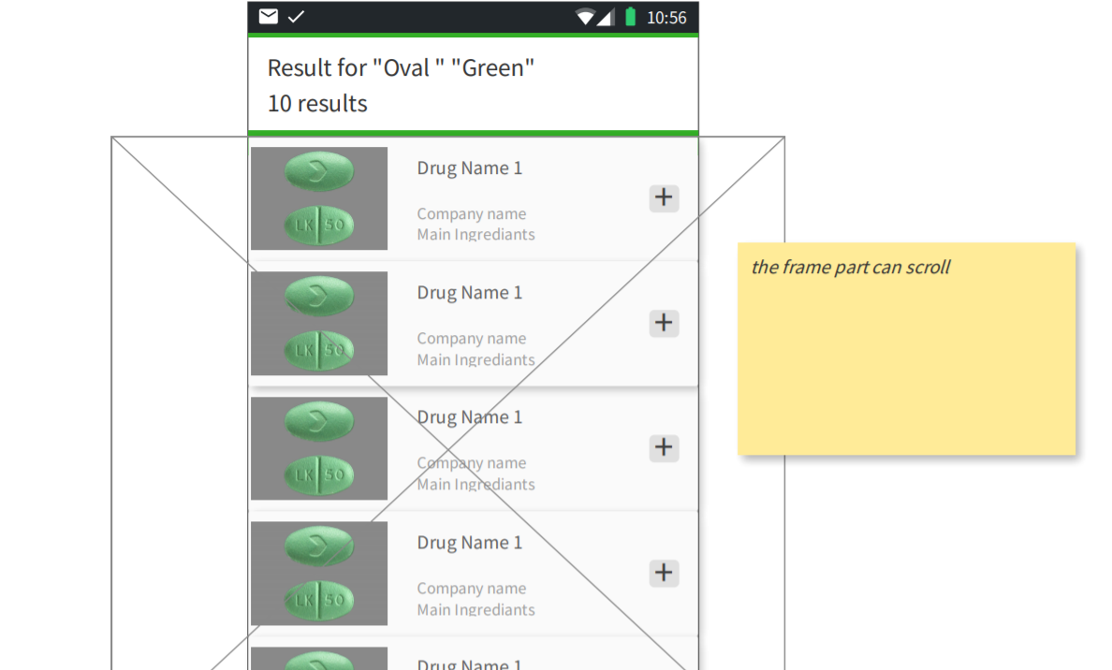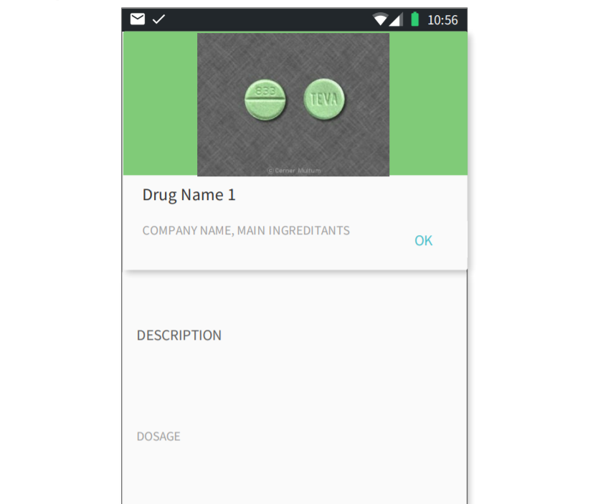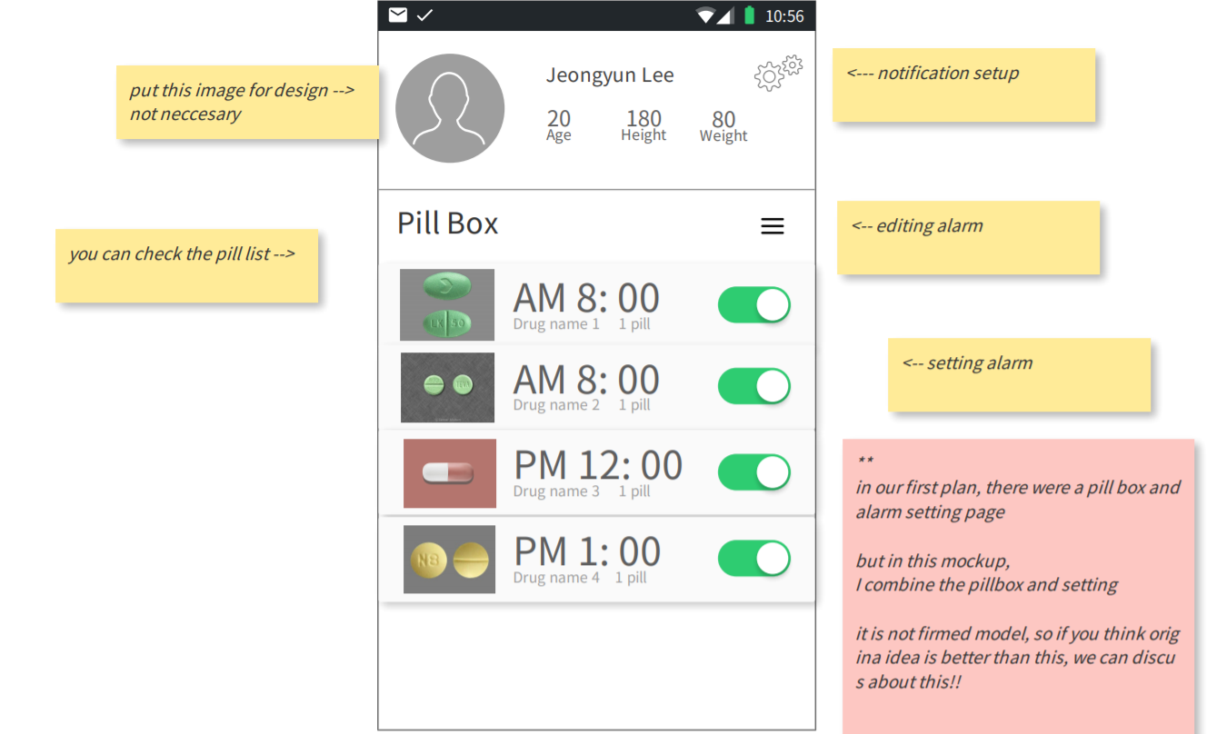

As the previous pictures show we build the mockup to understand how our app is going to be. The app will allow the user to have an account so he or she can make a search for a medicine and add it to the list and set alarms that will remind the users about the pill time. Also our app will include notification features so we can give the user some daily instructions that are related to the user's health.

Economic Viability:

A statement of cash flow is a financial document used in conjunction with balance sheets and income statements. Companies will use these financial statements to create a complete financial report.

The below link leads to the Economic Viability:

<https://docs.google.com/spreadsheets/d/1IqXhbGNB2awalN9h0mpop3EdCRJC8l8B/edit#gid=606687104>

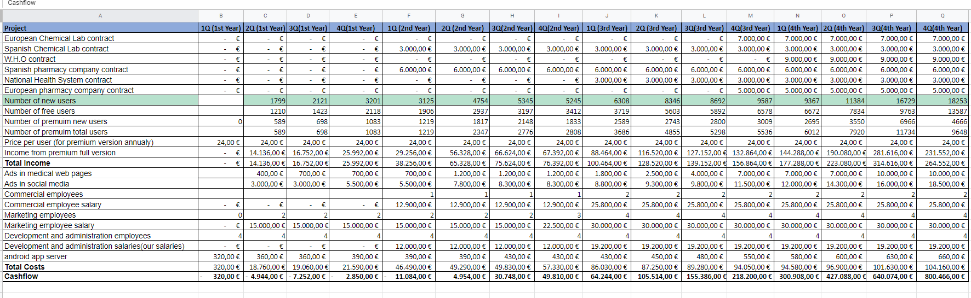

**Our resources of Income**

We will have more than one resource for income which are:

1. Signing contracts: One of our main resources of income is signing contracts with pharmacies, pharmacists companies and supplement companies, so we are going to put some ads in our application to get revenue from them. In the list of contracts in our Incomes (from rows 5 - 10: all those rows are showing the contracts that we are going to login in different fields and with different companies), we will start signing our contracts from the 1st quarter of the 2nd year; this is because we will hire our first commercial employee at the 1st quarter of the 2nd year by then, who would initiate the contracting process with respect to the Incomes. So the signing contract income is related to the number of commercial employees as shown in the previous figure (cash flow table). We will start getting more revenue from contracts when we will hire more commercial employees and also it is related to the number of users who are using our app because when we have more users we can convince more companies to sign with us.
2. Premium users/subscriptions: One of our main resources of income is getting revenue from users by creating a premium version of our application that has more features (like setting alarms and getting caution notifications) than the free one. We will price our premium subscription for 2€ monthly (24€ yearly) which is a very fair and cheap price compared to what our app is offering.

**Our Costs**

We will have more than one costs which includes:

1. Salaries: There would be 3 different salaries that will be included which are:
2. Commercial Employee salary: The commercial employees are those employees who deal with the relationship and financial factors of the company in getting new contracts for the growth of the company. Moreover, like a Business developer.  
   The salaries of the commercial employees have been kept lower in the 2nd year because of the number of the commercial employees. We would contract more number of employees after the 2nd year when the need arises.  
   This is the link for the average salary of a commercial employee (in Spain): <https://www.glassdoor.es/Sueldos/spain-commercial-manager-sueldo-SRCH_IL.0,5_IN219_KO6,24.htm?countryRedirect=true>
3. Marketing Employee Salary: The marketing employees are those employees who monitor market trends, create advertising campaigns, develop pricing strategies and target strategies based on demographic data and work with the company to develop more awareness of what they offer. We will start to hire the marketing team from the 2nd quarter of the 1st year and provide their salaries that would benefit us to achieve users from the 2nd quarter.  
   This is the link for the average salary of a marketing employee (in Spain): <https://www.glassdoor.es/Sueldos/madrid-marketing-sueldo-SRCH_IL.0,6_IM1030_KO7,16.htm?countryRedirect=true>
4. Development and Administration salary: The Development and Administration is a team that runs the process of guiding an organisation toward the achievement of progressive political, economic and social objectives that are authoritatively determined in one manner or the other. In our case, we as a team have decided to work in the development part and develop the application. This team would be responsible for taking important decisions about the various business factors.  
   The Development and Administration team’s salary would also be initiated from the 2nd year with low salary and then we will increase it in the upcoming years. This is because we are parties in this business so we have to invest more on it especially in the first two years to be a successful business in the future.
5. Servers: An app hosting platform can cost around 320€/quarter which would be increased as the development of the application changes/modifies with new/updated features. The cost of the server increases when the number of users increases.
6. Advertisements: We have divided the ad postings on the medical website pages and on social media sites (like Facebook,Instagram and Youtube). For the ad postings, we have invested more on social media platforms than on medical websites. This is because now-a-days, people spend most of their time on social media more than on medical sites. The number of users are related to ads because the more we invest in advertisements the more we will get more new users. As shown in the previous figure, the number of users are increasing while the amount of investment on the advertisements gets increased.

**Our Workzone**

We have decided to create a virtual office and work as an online company as it would lead to cost reduction and reduce other expenses that includes the different equipment, electricity, etc.

In addition, our application is an online service so there would be online contact with our customers to solve their queries.

We have decided to assign the following post:

*Chief Executive Officer*: Yoon

*Chief Technology Officer*: Eyad

*Chief Marketing Officer*: Marc

*Chief Financial Officer*: Ronnel

In the workforce, we as a team ourselves have decided to build and develop the application. We are trying to follow the American system such that every employee has their own equipment to work on. It will be better to reduce the cost. Also our workforce will increase every year or maybe quarter because we will get new users so we need more employees to manage and organize the business.

**NPV**

In the NPV sheet, the values for each year have been received on the basis of the cash flow sheet with respect to every single quarter in every year. The first year of the NPV sheet value would be the cash flow of the last quarter of the first year in the cashflow. The values of the remaining years in the NPV sheet would be achieved by calculating the total of the income and cost subtraction quarterly and then we implement the NPV formula.

**IRR**

The calculation in the NPV sheet yearly values are the same in the IRR sheet as well and then we implement the IRR formula.

**Payback**

For the Payback, the values are achieved by summing up the previous year’s value with the IRR and NPV and then we implement the Payback formula.

**What-if**

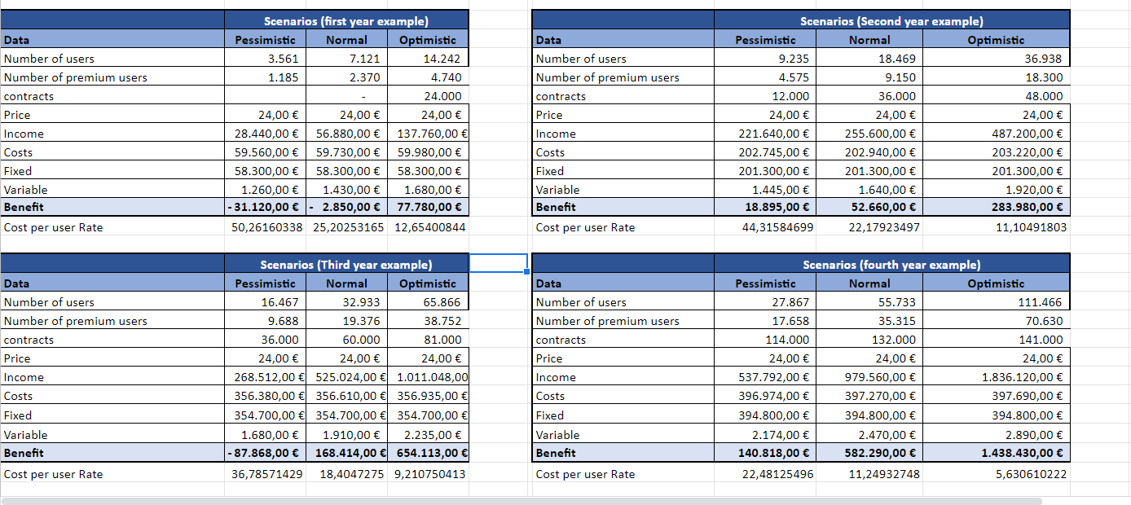

In the What-if scenario, we will see the 3 different users and the estimation of their values:

*Pessimistic*: The values in this column have been achieved on the basis of the Normal users. These values should be half of the Normal users (50%). We tried to assume the worst case scenario and we found that when we decrease it by 50% it will be the worst case.

*Normal*: The values in this column have been achieved on the basis of the total number of users from the cash flow sheet for a particular year. For example, in the first year example, we have included a sum of the total number of users of all the quarters of the 1st year. Also the cost and income had been taken from the cash flow sheet.

*Note:* The ‘Fixed’ are the fixed costs that will never be changed in our table that includes salaries and advertisement.The variable one that includes the server cost (Firebase).

*Optimistic*: The values in this column have been achieved on the basis of Normal users. These values should be double or more than the Normal users (100%). We tried to assume the best case scenario and we found that when we increase it by 100% it will be the best case.

Cost per user rate has also been included in the sheet. We achieve these values while calculating the cost per the number of premium users.

We added cost per user rate row to calculate how much it will be the percentage of losing and gaining money in the pessimistic and optimistic. As per the above figure, there is a change in the percentage every year. For example, in the first year, we will lose around 50% if we faced pessimistic scenario and we will gain around 12.6% if we face an optimistic scenario. It will be the same idea with the other years but with different rates.